Project Design Phase-II
Data Flow Diagram & User Stories

Date | 30 June 2026
Team ID
Project Name | A Comprehensive Measure of Well-Being
Maximum Marks | 4 Marks

Data Flow Diagrams:
A Data Flow Diagram (DFD) is a traditional visual representation of the information flows within a system. A neat and clear DFD can depict the right amount of the system requirement graphically. It shows how data enters and leaves the system, what changes the information, and where data is stored.

Example: (Simplified)
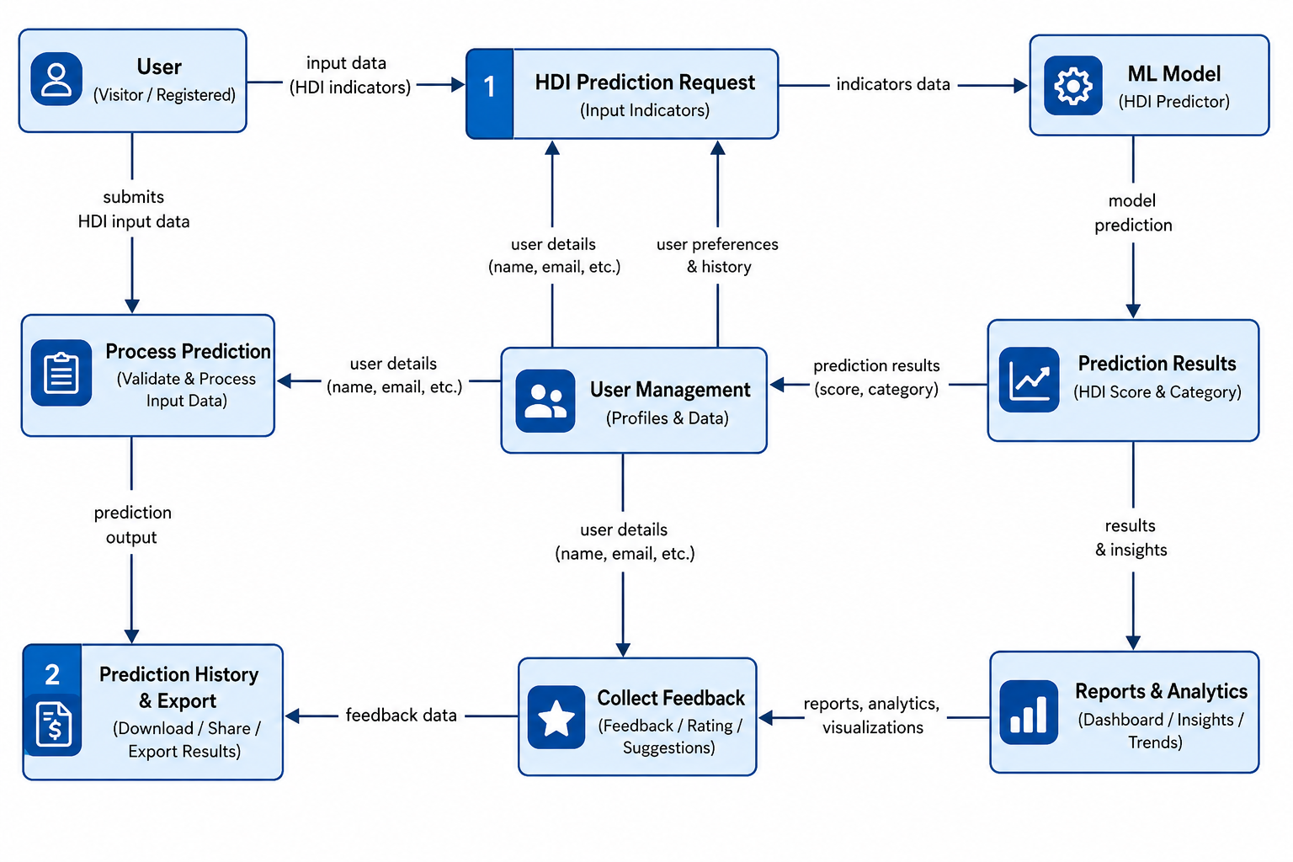


User Stories
Use the below template to list all the user stories for the product.
User Type | Functional Requirement (Epic) | User Story Number |  | User Story / Task | Acceptance criteria | Priority | Release
Customer (Mobile user) | Registration | USN-1 |  | As a user, I can register for the application by entering my email, password, and confirming my password. | I can access my account / dashboard | High | Sprint-1
 |  | USN-2 |  | As a user, I will receive confirmation email once I have registered for the application | I can receive confirmation email & click confirm | High | Sprint-1
 |  | USN-3 |  | As a user, I can register for the application through Facebook | I can register & access the dashboard with Facebook Login | Low | Sprint-2
USN-4 (Gmail Registration) |  | USN-4 |  | As a user, I can register for the application through Gmail | Acceptance Criteria | Medium | Sprint-1
USN-5 (Login) | Login | USN-5 |  | As a user, I can log into the application by entering email & password | Acceptance Criteria | High | Sprint-1
Dashboard Epic | Dashboard | USN-6 |  | As a user, I want to view a personalized dashboard summary so I can see my active profile details and main actions. | Full Workflow | High | Sprint-2
Customer (Web user) | Registration / Login | USN-7 |  | As a web user, I want a responsive web interface to register and log into my account | Web interface mirrors mobile functionality and matches design mockups across desktop browsers | High | Sprint-2
Customer Care Executive | Executive Support Ticket Management |  | USN-8 | As an executive, I want to view a list of open customer support queries so I can resolve them. | Executive can search, filter, and update the status of support requests from a central queue. | High | Sprint-3
Administrator | User Management | USN-9 |  | As an admin, I want to view and manage user accounts so I can block or unblock users violating terms. | Admin can view user profiles and toggle account status with a strict log of administrative actions. | Medium | Sprint-3

